Department of Computer Science and Engineering

Software Architecture & Design
Specification
Student Attendance Management System (SAMS)
Prepared by Nyssa Bansal, Ponakala Yathish, Prathamesh Kumar Singh, Rahul Dutta
PES University
05-10-2026
Prepared in accordance with the IEEE standard document structure
PES University | Software Engineering Mini-Project | Team 1
Department of Computer Science and Engineering

Table of Contents

1. Introduction
1.1 Purpose
1.2 Scope
1.3 Audience
1.4 Definitions

2. Document Overview
2.1 How to Use This Document
2.2 Related Documents

3. Architecture
3.1 Goals & Constraints
3.2 Stakeholders & Concerns
3.3 Component (UML) Diagram
3.4 Component Descriptions
3.5 Chosen Architecture Pattern and Rationale
3.6 Technology Stack & Data Stores
3.7 Risks & Mitigations
3.8 Traceability to Requirements
3.9 Security Architecture

4. Design
4.1 Design Overview
Department of Computer Science and Engineering
4.2 UML Sequence Diagrams
4.3 API Design
4.4 Error Handling, Logging & Monitoring
4.5 UX Design
4.6 Open Issues & Next Steps

5. Appendices
5.1 Glossary
5.2 References
5.3 Tools
Department of Computer Science and Engineering

Revision History
Version | Date | Author | Change summary
1.0 | 05-Oct-2026 | Team 1 | Initial architecture and design for Part-1 submission

Approvals
Role |  | Name | Signature / Date
Project guide / reviewer
Architect (team) |  | Prathamesh Kumar Singh
QA Lead (team) |  | Nyssa Bansal
Project | Student Attendance Management System (SAMS)
Document | Software Architecture and Design Specification (SAD) - IEEE 42010 / IEEE 1016 structure
Version | 1.0
Authors | Team 1 (see team members below)
Date | 05-Oct-2026
Status | Draft
Related documents | SAMS SRS v1.0; SAMS Software Test Plan v1.0

Team Members
Name | USN | PRN
Nyssa Bansal | PES1UG24CS306 | PES1202400586
Ponakala Yathish | PES1UG24CS322 | PES1202400104
Prathamesh Kumar Singh | PES1UG24CS341 | PES1202400014
Rahul Dutta | PES1UG24CS358 | PES1202400620
Department of Computer Science and Engineering
Department of Computer Science and Engineering

1. Introduction

1.1 Purpose
This document specifies the architecture and design of the Student Attendance Management System (SAMS) v1.0. It explains how the requirements of the SRS are realised by components, patterns, interfaces and security controls, and gives enough design detail (sequence diagrams, API definitions, error handling) for implementation and testing to start.

1.2 Scope
Covers the complete SAMS product: authentication, user/course/enrolment management, class sessions and attendance marking, attendance viewing, correction requests, reports (on-screen, PDF/CSV, scheduled), e-mail notifications and audit logging. It does not cover the institution's SMTP relay, network or hosting infrastructure.

1.3 Audience
Developers (team members), QA engineers writing the test plan, security reviewers, the course instructor, and future maintenance teams.

1.4 Definitions
Term | Definition
SAMS | Student Attendance Management System.
ADR | Architecture Decision Record: a short record of one significant architectural decision, its context and consequences.
RBAC | Role-Based Access Control.
JWT | JSON Web Token; signed token carrying the user identity and role.
TLS | Transport Layer Security.
STRIDE | Threat classification: Spoofing, Tampering, Repudiation, Information disclosure, Denial of service, Elevation of privilege.
DTO | Data Transfer Object: the shape of data sent over the API, separate from database entities.
IDOR | Insecure Direct Object Reference: accessing another user's object by changing an ID.
OD | On-Duty attendance status (counts as attended).
Department of Computer Science and Engineering

2. Document Overview

2.1 How to Use This Document
Section 3 describes the architecture (component diagram, pattern, technology, risks, traceability, security architecture). Section 4 describes the detailed design (sequence diagrams, API definitions, error handling, logging, monitoring, UX). Readers who implement a feature should read the matching row in Section 3.8, the sequence diagram in Section 4.2 and the API definition in Section 4.3.

2.2 Related Documents
Document | Relationship
SAMS Software Requirements Specification (SRS) v1.0 | Source of all requirement IDs (SAMS-F, SAMS-NF, SAMS-SEC). Section 3.8 traces them to components.
SAMS Software Test Plan (STP) v1.0 | Uses the API catalogue, error codes and security architecture of this document for test design; contains the test cases.
Requirements Traceability Matrix (SRS Appendix C) | Links requirements to architecture, design, code and test case references.

3. Architecture

3.1 Goals & Constraints
Architecture goals (quality attributes in order of priority) and the SRS requirements that set their targets:
Priority | Goal | Target | SRS reference
1 | Security and privacy of student data | RBAC on every endpoint; TLS 1.2+; bcrypt; 0 High/Critical ZAP findings | SAMS-SEC-001 to SEC-010
2 | Correctness and integrity of attendance records | One record per student per session; percentages exact to 2 decimals; every edit audited | SAMS-F-024, F-025, NF-012
3 | Performance at class start | p95 roster <= 2 s, submit <= 3 s at 200 concurrent users | SAMS-NF-001, NF-002, NF-004
Department of Computer Science and Engineering
Priority | Goal | Target | SRS reference
4 | Availability and recoverability | 99.5% in teaching hours; RPO <= 24 h;  RTO <= 4 h | SAMS-NF-005, NF-006
5 | Maintainability and testability | Layered modules; service-layer coverage >= 70% | SAMS-NF-009
6 | Usability and portability | Responsive UI; runs on Linux/Windows, JDK 17 | SAMS-NF-007, NF-008, NF-010
Constraints:
●Technology: Java 17 and Spring Boot (allowed stack in the project sheet), MySQL 8, React front end.
●Only free / open-source tools; team of four students with a fixed academic schedule, so the architecture must be simple enough to build and test within one semester.
●Compliance with the DPDP Act, 2023 and OWASP ASVS Level 1 (SRS 6.3.4).
●Deployment on a single server or VM (Docker Compose) provided by the institution; outbound SMTP relay available.
●All times in IST.
Department of Computer Science and Engineering

3.2 Stakeholders & Concerns
Stakeholder | Concerns | Addressed in
Students | See correct attendance; privacy of own data; timely low-attendance warnings. | 3.9, 4.3 (API-ATT-01),  SD-02
Faculty | Fast, simple marking at the start of class; ability to correct mistakes; automatic reports. | SD-02, SD-03, 4.5
Administrators  (academic office) | Manage users and courses in bulk; reliable reports; audit trail. | 4.3 (API-ADM-*), 4.4
Institution management / regulators | Compliance (DPDP Act); data retention; accountability. | 3.9, 4.4
Developers (the team) | Modularity; clear interfaces; testability; simple deployment. | 3.3, 3.5, 4.1
QA engineers | Testable interfaces, deterministic error codes, controllable clock. | 4.3, 4.4
Operations / maintenance | Monitoring, backups, easy deployment and upgrade. | 3.6, 3.7, 4.4

3.3 Component (UML) Diagram
Figure 1 shows the components of SAMS and their dependencies. Components are grouped into the layers of the chosen pattern (Section 3.5). Dashed arrows are asynchronous calls.
Department of Computer Science and Engineering
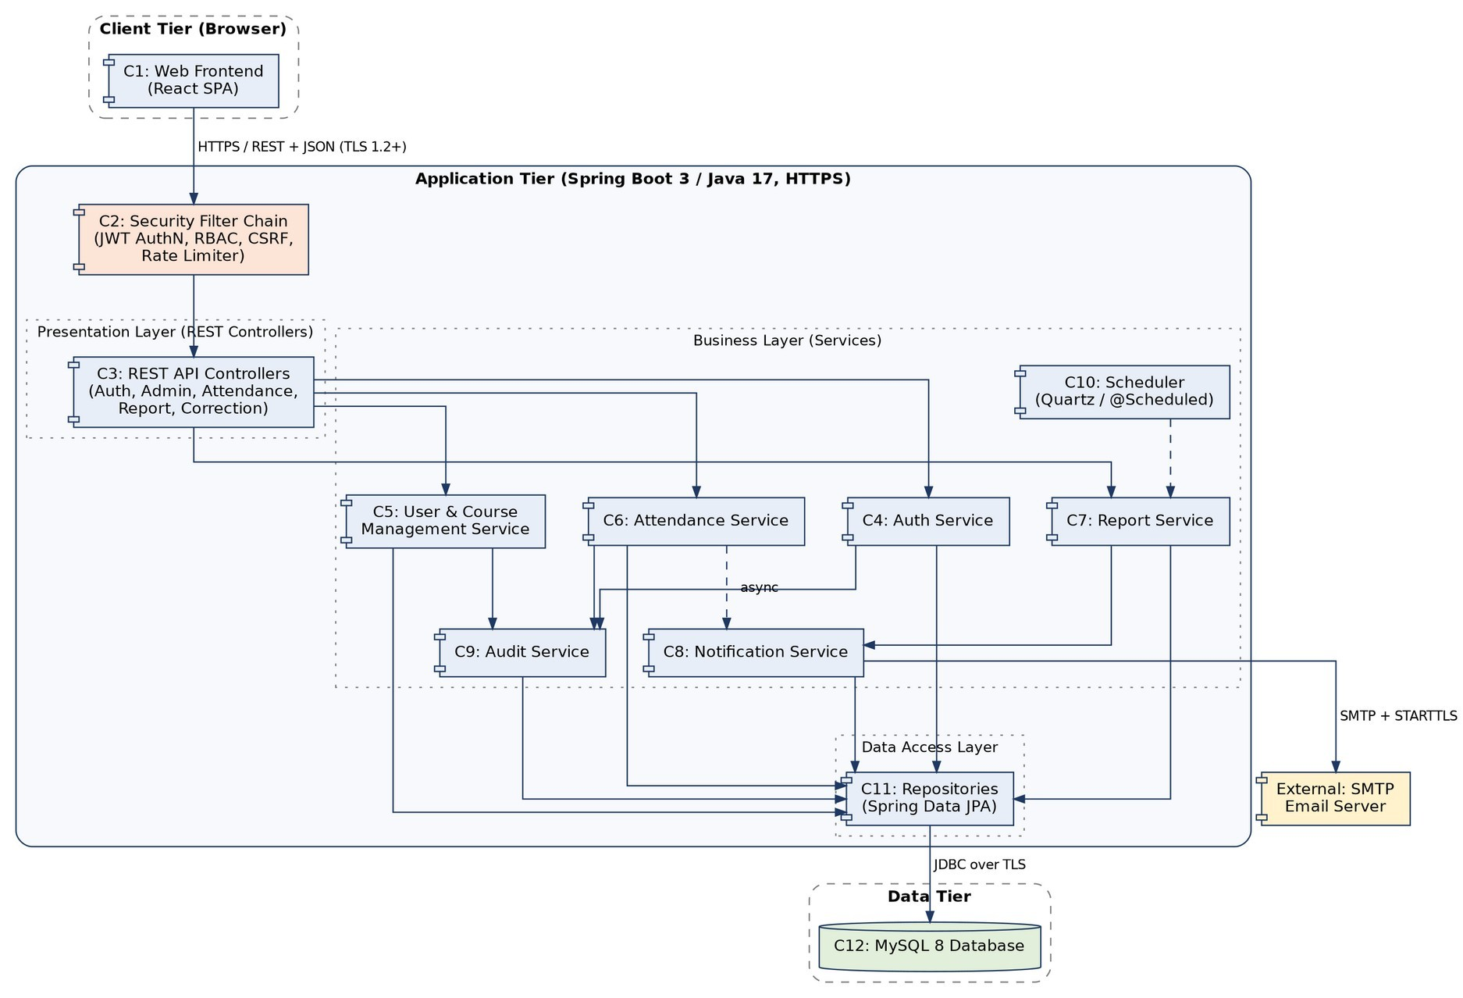
Figure 1: UML component diagram - SAMS Department of Computer Science and Engineering 3.4 Component Descriptions
ID | Component | Responsibilities
C1 | Web Frontend | React single-page application. Renders role-based screens and calls the REST API over HTTPS.
C2 | Security Filter Chain | Spring Security filters: JWT validation, role-based access control (RBAC), CSRF check, rate limiting, security headers.
C3 | REST API Controllers | Thin controllers (Auth, Admin, Session/Attendance, Correction, Report, Audit). Validate input, map DTOs, delegate to services.
C4 | Auth Service | Login, lockout, password reset, token issue/revoke, password hashing (bcrypt).
C5 | User & Course  Management Service | User accounts, course-sections, faculty assignment, enrolment (single and CSV bulk).
C6 | Attendance Service | Class sessions, roster, attendance submission/edit, percentage calculation, correction requests, object-level authorisation.
C7 | Report Service | Student-wise and defaulter reports, PDF/CSV export, weekly/monthly report jobs.
C8 | Notification Service | Asynchronous e-mail alerts and report delivery with retry (3 x 5 min).
C9 | Audit Service | Append-only audit trail of security- and data-relevant events.
C10 | Scheduler | Cron-style triggers (Spring @Scheduled / Quartz) for weekly and monthly reports and retries.
C11 | Repositories (Data Access Layer) | Spring Data JPA repositories; parameterised queries only.
C12 | MySQL 8 Database | Relational store for all persistent data.
Interfaces between components
Provider | Interface (provided) | Consumers
C3 REST API Controllers | REST/JSON over HTTPS: /api/v1/... (Section 4.3) | C1 Web Frontend
C4 Auth Service | authenticate(), issueToken(), validateToken(), requestReset(), confirmReset() | C3, C2
C5 User & Course Management Service | createUser(), updateUser(), createCourseSection(), enrol(), importEnrolments() | C3
Department of Computer Science and Engineering
Provider | Interface (provided) | Consumers
C6 Attendance Service | createSession(), getRoster(), submitAttendance(), editAttendance(), getStudentSummary(), raiseCorrection(), decideCorrection() | C3, C7
C7 Report Service | studentWise(), defaulters(), export(format), runWeekly(), runMonthly() | C3, C10
C8 Notification Service | sendLowAttendanceAlert(), sendReport(), sendResetLink() with retry | C4, C6, C7
C9 Audit Service | log(event) - append only; query(filter) | C3, C4, C5, C6, C7
C11 Repositories | Spring Data JPA interfaces per aggregate | C4 to C9

3.5 Chosen Architecture Pattern and Rationale
Pattern: layered (3-tier) architecture implemented as a modular monolith. The layers are Presentation (React frontend, REST controllers), Business (services), Data Access (repositories) and Data (MySQL). Within the business layer the code is split into modules (auth, admin, attendance, report, notification, audit) with explicit service interfaces; a module may call another only through its service interface. A cross-cutting security filter chain protects all REST calls.
Alternative | Why not chosen
Microservices | Too complex for 5,000 students and 200 concurrent users and for a four-member team (service discovery, distributed transactions, many deployments). A monolith meets NF-001 to NF-004 more simply.  Modules keep the option to split later.
Client-server with server-rendered pages only | Less responsive on phones; harder to reuse the API for the future mobile app.
Event-driven architecture with a message broker | Only two asynchronous flows (e-mail, scheduled reports) exist; Spring @Async with a database-backed retry is enough (ADR-004).
Department of Computer Science and Engineering

Architecture decision records
ADR | Decision | Context and consequences
ADR-00 1 | Layered modular monolith, one deployable JAR. | Simplest to build, test and deploy; transactions are local (attendance + audit in one transaction); scaling is vertical, which is enough for the target load. Risk: modules may become coupled, so package-level rules are enforced with ArchUnit tests.
ADR-00 2 | Session identity as signed JWT  (15 min) in an HttpOnly, Secure, SameSite=Strict cookie, plus CSRF token header. | Protects the token from XSS (not readable by script) and from CSRF; stateless server. Alternative localStorage tokens rejected because XSS could steal them. Logout invalidation uses a short server-side deny-list of token IDs until expiry.
ADR-00 3 | MySQL 8 relational database. | Data is highly relational with integrity rules  (UNIQUE(session, student), foreign keys, transactions); the team knows SQL; NoSQL gives no benefit.
ADR-00 4 | Asynchronous notifications using Spring @Async and a report_log / outbox table with scheduled retry (3 x 5 min). | Faculty submission never waits for e-mail (NF-002); retries survive a restart because state is in the database.  No message broker to operate.
ADR-00 5 | Attendance percentage computed on demand by SQL aggregation with indexes, not stored. | Always consistent with edits (NF-012); at most about 60 sessions per course, so cost is low. Indexes on  (student_id, session_id) and (section_id, session_date).
ADR-00 6 | Inject java.time.Clock into all time-dependent code. | Lets tests control the 24 h edit window, 7-day correction window, 15-min timeout and Monday 06:00 job (STP risk table).
Department of Computer Science and Engineering

3.6 Technology Stack & Data Stores
Area | Technology | Notes
Frontend | React 18, Vite, React Router, Axios, plain CSS / CSS modules | Responsive, accessible components; talks to API only.
Backend | Java 17, Spring Boot 3.x (Web, Validation, Data JPA, Security, Mail, Actuator), Maven | Spring Security for filters and RBAC; BCryptPasswordEncoder  (cost 12).
Token | jjwt (HS256 or RS256); secret in environment variable | 15-minute expiry; claims: sub, role, jti.
Scheduling | Spring @Scheduled (cron, zone Asia/Kolkata) | Weekly: 0 0 6 * * MON; monthly: 0 0 6 1 * *.
Reports | OpenPDF (PDF), OpenCSV (CSV) behind a  ReportExporter strategy interface | CSV cells sanitised against formula injection  (SAMS-SEC-010).
Rate limiting | Bucket4j in a servlet filter | 100 requests/min per IP; 20/min on login (SAMS-SEC-006).
Data store | MySQL 8.0 (InnoDB, utf8mb4), Flyway migrations | Schema in Section 4.1; nightly mysqldump to an encrypted file, 14 days retention (NF-006).
Logging / monitoring | Logback (JSON), Micrometer + Prometheus, Grafana (optional), Spring Actuator health | See Section 4.4.
Web server / deployment | Nginx (TLS termination, static files, HTTP to  HTTPS redirect, security headers); Docker  Compose: nginx, app, mysql, backup job;  MailHog in TEST | Runs on Linux or Windows hosts (NF-010).
Test and quality | JUnit 5, Mockito, Testcontainers, JaCoCo, ArchUnit, Selenium, JMeter, OWASP ZAP | See the STP.
Department of Computer Science and Engineering 3.7 Risks & Mitigations
Risk | Impact | Mitigation
Application or database server  failure during teaching hours (NF-005) | Faculty cannot mark attendance | Container restart policy; health checks and alerts; nightly backup; documented restore procedure tested against RTO 4 h (NF-006).
Data loss or corruption | Loss of academic records | Daily backup (RPO 24 h), transactional writes, no physical deletes (BR-6), backup copy kept off the server.
Peak load at class start (e.g., 08:30) breaks performance targets | Slow roster/submit | Indexes, connection pool tuning (20 connections), asynchronous notifications, JMeter tests early in PERF environment.
SMTP relay outage | Alerts and reports delayed | Retry 3 x 5 min, FAILED status visible to Administrator, manual resend (ADR-004).
Authorisation bug exposes another student's data (IDOR) | Privacy breach | Object-level checks in services (not only controllers), access-matrix test TC-SEC-01, code review checklist.
Team inexperience with Spring Security | Misconfiguration | Use framework defaults, ASVS checklist, pair review, ZAP scans in CI.
Duplicate or concurrent submissions | Inconsistent records | Database UNIQUE(session_id, student_id), transaction per submission, HTTP 409.
Time and timezone mistakes | Wrong windows or schedule times | Single Clock bean, Asia/Kolkata zone, tests with fixed clock (ADR-006).
Scope larger than the semester allows | Incomplete product | Priorities in SRS (High first); correction requests and scheduled monthly reports can slip without breaking the core.

3.8 Traceability to Requirements
Every SRS requirement is realised by the components below (IDs from Section 3.4) and by the design elements in Section 4 (SD = sequence diagram, API = interface definition). The same links appear in SRS Appendix C.
Requirement ID | Requirement (short) | Components | Design reference
SAMS-F-001 | Login with e-mail and password (<= 3 s) | C1, C2, C3, C4, C11 | SD-01; API-AUTH-01
Department of Computer Science and Engineering
Requirement ID | Requirement (short) | Components | Design reference
SAMS-F-002 | Lock account 15 min after 5 failed logins | C4, C11 | SD-01; API-AUTH-01
SAMS-F-003 | Single-use password-reset link (30 min) | C4, C8, C11 | API-AUTH-03; API-AUTH-04
SAMS-F-004 | Logout and 15-minute inactivity timeout | C2, C4 | API-AUTH-02
SAMS-F-010 | Create / update / deactivate users | C3, C5, C11 | API-ADM-01
SAMS-F-011 | Reject duplicate ID or e-mail | C5, C11 | API-ADM-01
SAMS-F-012 | Create course-section and assign faculty | C3, C5, C11 | API-ADM-02
SAMS-F-013 | Enrol students singly or by CSV (<= 1,000 rows) | C3, C5, C11 | API-ADM-03
SAMS-F-020 | Create class session; reject overlap | C3, C6, C11 | API-SES-01
SAMS-F-021 | Roster shows all students  UNMARKED | C3, C6, C11 | SD-02; API-SES-02
SAMS-F-022 | Mark P / A / OD; submit only when complete | C1, C3, C6, C11 | SD-02; API-SES-03
SAMS-F-023 | Only assigned faculty can mark (else 403) | C2, C6 | SD-02; API-SES-03
SAMS-F-024 | One record per student per session (else 409) | C6, C11 | SD-02; API-SES-03
SAMS-F-025 | Edit window 24 h; edit data stored with reason | C6, C9, C11 | API-SES-04
SAMS-F-030 | Student views own held / attended / % | C1, C3, C6, C11 | API-ATT-01
SAMS-F-031 | Faculty views assigned sections only | C2, C6 | API-ATT-02
SAMS-F-032 | Red highlight below threshold | C1, C6 | API-ATT-01
SAMS-F-040 | Student correction request within 7 days | C3, C6, C11 | API-COR-01
SAMS-F-041 | Faculty approves / rejects; e-mail within 5 min | C6, C8, C9 | API-COR-02
SAMS-F-050 | Student-wise attendance report | C3, C7, C11 | API-REP-01
SAMS-F-051 | Defaulter report (threshold) | C3, C7, C11 | API-REP-02
SAMS-F-052 | Export PDF and CSV | C7 | API-REP-01; API-REP-02
SAMS-F-053 | Weekly report Monday 06:00 IST | C7, C8, C10 | SD-03
Department of Computer Science and Engineering
Requirement ID | Requirement (short) | Components | Design reference
SAMS-F-054 | Monthly report on 1st, 06:00 IST | C7, C8, C10 | SD-03
SAMS-F-060 | Low-attendance e-mail within 5 min | C6, C8 | SD-02
SAMS-F-061 | E-mail retry 3 x 5 min; final status | C8, C11 | SD-03
SAMS-F-070 | Audit log records key events | C9, C11 | SD-01; SD-02; API-AUD-01
SAMS-F-071 | Audit log filter; read-only | C3, C9 | API-AUD-01
SAMS-NF-001 | Roster load <= 2 s (p95, 200 users) | C1, C3, C6, C11, C12 | API-SES-02
SAMS-NF-002 | Submit 100 students <= 3 s (p95) | C3, C6, C11, C12 | SD-02; API-SES-03
SAMS-NF-003 | Report generation <= 10 s | C7, C11, C12 | API-REP-01
SAMS-NF-004 | Capacity: 5,000 students / 200 concurrent users | All | Section 3.5 (ADR-001)
SAMS-NF-005 | Availability >= 99.5% (08-20 IST, Mon-Sat) | C2-C12 (deployment) | Section 4.4 (monitoring)
SAMS-NF-006 | Daily backup; RPO <= 24 h, RTO <= 4 h | C12 | Section 3.7
SAMS-NF-007 | Mark 60 students in <= 2 min | C1 | Section 4.5
SAMS-NF-008 | Responsive 360-1920 px; Chrome/Firefox/Edge | C1 | Section 4.5
SAMS-NF-009 | Service-layer unit-test coverage >=  70% | C4-C9 | Section 3.5
SAMS-NF-010 | Runs on Linux and Windows (JDK 17, MySQL 8) | C3-C12 | Section 3.6
SAMS-NF-011 | Keyboard operable; WCAG 2.1 AA contrast | C1 | Section 4.5
SAMS-NF-012 | Percentage computed correctly (2 decimals) | C6, C7 | API-ATT-01
SAMS-SEC-00 1 | RBAC and object-level authorisation | C2, C6 | Section 3.9; all API-*
SAMS-SEC-00 2 | Password policy; bcrypt hashing | C4, C11 | Section 3.9; API-AUTH-01
SAMS-SEC-00 3 | TLS 1.2+; HTTP redirected | C1, C2, C11, C12 | Section 3.9
SAMS-SEC-00 4 | Input validation; injection / XSS /  CSRF | C2, C3, C11 | Section 3.9; Section 4.4
Department of Computer Science and Engineering
Requirement ID | Requirement (short) | Components | Design reference
SAMS-SEC-00 5 | HttpOnly / Secure / SameSite token cookie | C2, C4 | SD-01; API-AUTH-01; API-AUTH-02
SAMS-SEC-00 6 | Rate limiting (HTTP 429) | C2 | Section 3.9
SAMS-SEC-00 7 | Append-only audit; no secrets in logs | C9, C11 | Section 4.4; API-AUD-01
SAMS-SEC-00 8 | Data minimisation; only SMTP relay | C5, C8, C12 | Section 3.9
SAMS-SEC-00 9 | Generic errors, no leakage | C3 (exception handler) | Section 4.4
SAMS-SEC-01 0 | CSV upload limits; CSV-injection protection | C5, C7 | API-ADM-03; API-REP-01
Examples: SAMS-F-001 (Login) -> C4 Auth Service, C2 Security Filter Chain; SAMS-F-022 (Mark attendance) -> C6 Attendance Service; SAMS-F-053 (weekly report) -> C10 Scheduler, C7 Report Service, C8 Notification Service.

3.9 Security Architecture
3.9.1 Security principles and trust boundaries ●Defence in depth: controls at the edge (Nginx, rate limit), application (filters, RBAC, validation) and data (least-privilege DB account, constraints, append-only audit).
●Least privilege: the application DB account has SELECT/INSERT/UPDATE on business tables, INSERT and SELECT only on audit_log, and no DDL rights at run time (Flyway uses a separate migration account).
●Secure by default: deny everything not explicitly allowed (Spring Security default deny; whitelist of public endpoints = login and password reset).
●Server-side enforcement: the browser is untrusted; every rule (roles, windows, ownership) is checked in C2/C6 regardless of the UI.
Trust boundary | Crossing | Protection
TB1: user's browser to  Nginx | HTTPS requests from the  Internet / intranet | TLS 1.2+, HSTS, rate limiting, security headers (CSP, X-Content-Type-Options, X-Frame-Options).
Department of Computer Science and Engineering
Trust boundary | Crossing | Protection
TB2: application to  MySQL | JDBC | TLS, private network (not exposed), dedicated least-privilege account, parameterised queries.
TB3: application to  SMTP relay | SMTP | STARTTLS, credentials in environment variables, no personal data beyond e-mail address, name and course info.

3.9.2 Threat model (STRIDE)
Threat | Example in SAMS | Mitigation (component) | Requirement
Spoofing | Attacker guesses or steals a password; forged token | bcrypt, password policy, lockout after 5 failures (counters kept per username even if it does not exist), signed 15-min JWT in  HttpOnly cookie, TLS (C2, C4) | SEC-002,  SEC-003,  SEC-005, F-002
Tampering | Student changes own attendance via API; edits role in token; SQL injection | RBAC and object-level checks, 24 h edit window, server-side validation, parameterised queries, JWT signature, DTO whitelist (no mass assignment), CSRF token (C2, C3, C6, C11) | SEC-001,  SEC-004,  SEC-005, F-023,  F-025
Repudiation | Faculty denies changing a record | Append-only audit with user, IP, time, old/new value and reason; audit write in same transaction as the change (C6, C9) | SEC-007, F-025, F-070
Information disclosure | IDOR on  /students/{id}/attendance; sniffing; verbose errors; secrets in logs; CSV leaks | Object-level authorisation, TLS everywhere, generic error model, log redaction,  role-limited exports, data minimisation (C2, C3, C6, C7) | SEC-001,  SEC-003,  SEC-008,  SEC-009
Denial of service | Login brute force; flood of requests; huge CSV; heavy report loops | Rate limiting 100/min and 20/min login, upload cap 2 MB and 1,000 rows, limit of 3 parallel report jobs, DB pool and request timeouts (C2, C5, C7) | SEC-006,  SEC-010, F-013
Elevation of privilege | Student calls /admin endpoints; role field sent in user update | /admin/** requires ROLE_ADMIN, role read from verified token and DB (not from request body), deny-by-default (C2, C3) | SEC-001
Department of Computer Science and Engineering

3.9.3 Security controls by layer
Layer / component | Controls | Requirement
Edge (Nginx) | TLS 1.2/1.3 only, strong ciphers, HTTP to HTTPS redirect, HSTS, request size limit, CSP and other headers. | SEC-003
C2 Security Filter  Chain | JWT validation, role check, CSRF token on  POST/PUT/PATCH/DELETE, Bucket4j rate limit (429 + Retry-After), CORS limited to the frontend origin. | SEC-001,  SEC-005,  SEC-006
C3 Controllers | Bean Validation on every DTO, central exception handler returning the standard error model, no stack traces. | SEC-004, SEC-009
C4 Auth Service | bcrypt hash, password policy, lockout, single-use reset tokens (random 256-bit, stored hashed, 30 min), token deny-list on logout. | SEC-002,  SEC-005,  F-002, F-003
C5 / C6 / C7 services | Object-level authorisation (faculty owns section; student owns record), business rule enforcement, CSV upload checks, CSV-injection sanitiser on export. | SEC-001, SEC-010
C9 Audit Service | Append-only table, retention 1 year, entries free of secrets. | SEC-007
C11 / C12 Data | JPA parameterised queries, least-privilege account, TLS JDBC, encrypted backups, only Appendix-B personal data stored. | SEC-004, SEC-008

3.9.4 Endpoint access matrix
This matrix is the reference for test case TC-SEC-01 (A = Allowed, O = own records only, S = assigned sections only, - = denied).
API | Endpoint group | Anonymou  s | Student | Faculty | Admin
API-AUTH-01, -03, -04 | Login, password-reset request/confirm | A | A | A | A
API-AUTH-02 | Logout | - | A | A | A
API-ADM-01 to -04 | /admin/** (users, course-sections, enrolment, settings) | - | - | - | A
API-SES-01, -02, -03 | Create session, roster, submit attendance | - | - | S | -
API-SES-04 | Edit attendance | - | - | S (within 24 h) | A
API-ATT-01 | Student attendance summary | - | O | - | -
Department of Computer Science and Engineering
API | Endpoint group | Anonymou  s | Student | Faculty | Admin
API-ATT-02 | Course-section attendance | - | - | S | A
API-COR-01 | Raise correction request | - | O | - | -
API-COR-02 | Decide correction request | - | - | S | -
API-REP-01, -02 | Reports and export | - | - | S | A
API-AUD-01 | Audit log | - | - | - | A

3.9.5 Data classification and protection
Class | Data | Protection
Secret | Password hashes, JWT signing key, DB and SMTP credentials, reset tokens | Hash/salt, environment variables or Docker secrets (never in Git), not logged, rotated at least once per semester.
Personal  (restricted) | Institution ID, name, e-mail, attendance records | Role-based access, TLS in transit, encrypted backups, retained per SRS Section 7, DPDP Act purpose limitation.
Internal | Audit log, report files, application logs | Admin-only access, redaction of personal data in logs (IDs only).

4. Design

4.1 Design Overview
The backend is a Spring Boot application organised in packages by module ( com.pes.sams.<module> ). Each module has web (controllers, DTOs), service (business rules, transactions), repo (JPA repositories) and domain (entities) sub-packages. The common module holds the security filters, error model, Clock bean and utilities.
Design element | Where used | Purpose
Layered separation (controller / service / repository) | All modules | Separation of concerns; services own transactions and business rules.
DTO + mapper | All controllers | API contract independent of database entities; prevents mass assignment.
Department of Computer Science and Engineering
Design element | Where used | Purpose
Repository pattern (Spring Data JPA) | C11 | Hides persistence; parameterised queries only.
Strategy: ReportExporter (PdfExporter, CsvExporter) | C7 | Add a format without touching report logic (F-052).
Observer: Spring ApplicationEvent  (AttendanceSubmittedEvent,  ReportGeneratedEvent) | C6, C7 to C8, C9 | Decouples notification and auditing from the main flow.
Chain of responsibility: servlet filter chain | C2 | Rate limit, authenticate, CSRF, authorise in a fixed order.
Global exception handler (@RestControllerAdvice) | C3 | One place that maps exceptions to the standard error JSON (Section 4.4).
Unit of work: @Transactional service methods | C5, C6 | Attendance rows and audit row commit or roll back together.
Key classes
Class | Module | Responsibility
AuthController / AuthService / LoginAttemptTracker | auth | Login, logout, reset; failed-attempt and lock tracking.
SecurityConfig, JwtAuthFilter, CsrfFilter, RateLimitFilter | common | Filter chain and role rules.
UserService, CourseSectionService, EnrolmentImportService | admin | Users, sections, single and CSV enrolment with row-level error report.
SessionService, AttendanceService, AttendanceCalculator | attendance | Sessions, roster, submit, edit window check, percentage calculation (single place for the formula, NF-012).
CorrectionService | attendance | Correction requests and decisions.
ReportService, ReportExporter, ReportScheduler | report | Report data, export strategies, weekly/monthly jobs.
NotificationService, MailSender, RetryJob | notify | Asynchronous e-mail with retry and final status.
AuditService, AuditListener | audit | Append-only logging of domain events.
GlobalExceptionHandler, ApiError, ErrorCode | common | Standard error model and codes.
Department of Computer Science and Engineering
Data model. Figure 2 shows the persistent entities (the conceptual model of SRS Figure 2 with keys). Important integrity rules are enforced in the database: UNIQUE(session_id, student_id) on attendance_record, UNIQUE(student_id, section_id) on enrollment, foreign keys on all references, CHECK on status values, and no UPDATE/DELETE privilege on audit_log for the application account. Main indexes: attendance_record(student_id, session_id), class_session(section_id, session_date), audit_log(timestamp_ist, user_id).
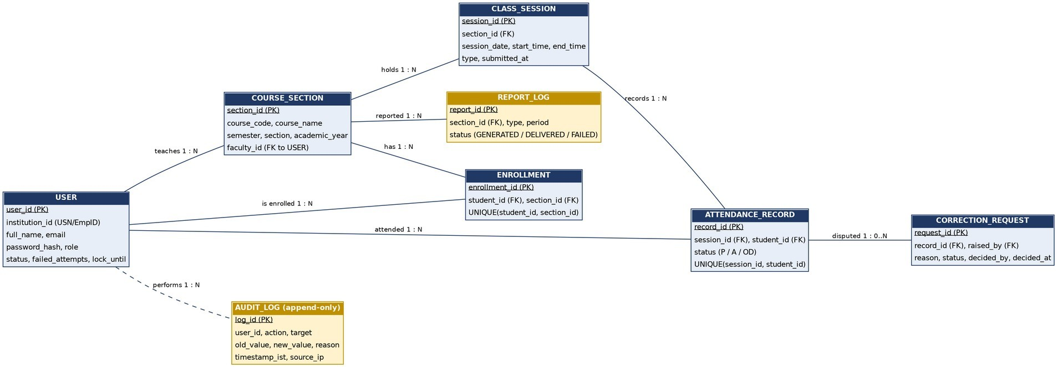
Figure 2: Persistent data model - SAMS

4.2 UML Sequence Diagrams
Three flows that are central to SAMS are shown: login with lockout (SD-01), marking attendance with audit and low-attendance alert (SD-02) and the scheduled weekly report with e-mail retry (SD-03). Message names match the interfaces in Section 3.4 and the API definitions in Section 4.3.
Department of Computer Science and Engineering

SD-01 Login with lockout (SAMS-F-001, F-002, SEC-002, SEC-005, F-070)
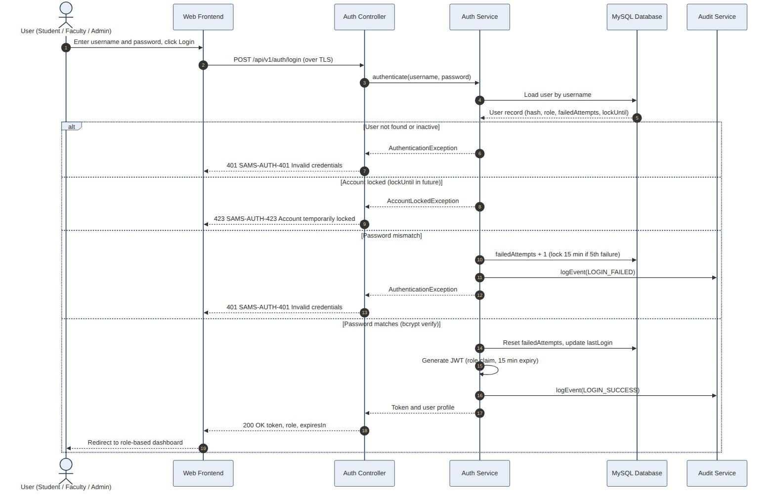
Figure 3: Sequence diagram SD-01 - Login
Department of Computer Science and Engineering

SD-02 Mark attendance (SAMS-F-021 to F-024, F-060, F-070, SEC-001, NF-002)
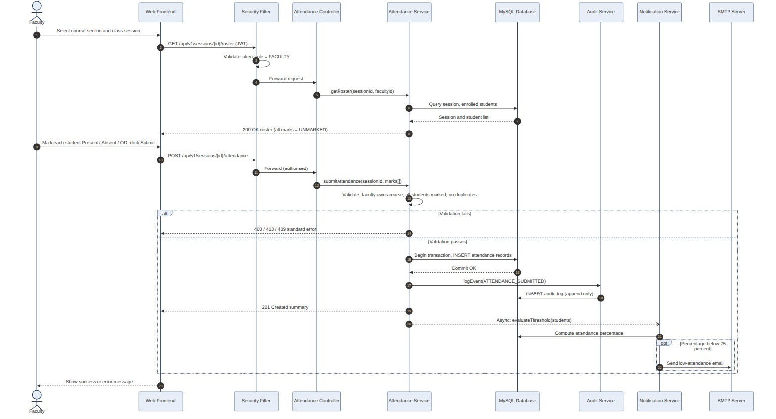
Figure 4: Sequence diagram SD-02 - Mark attendance
Department of Computer Science and Engineering

SD-03 Scheduled weekly report (SAMS-F-053, F-054, F-061)
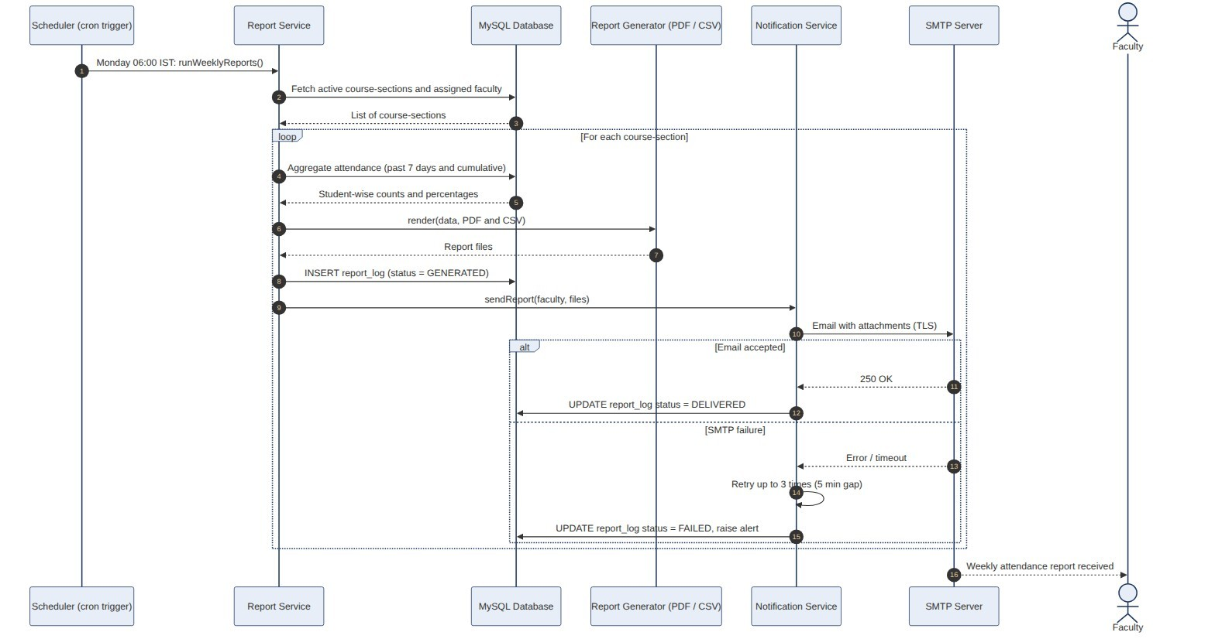
Figure 5: Sequence diagram SD-03 - Scheduled weekly report with e-mail retry

4.3 API Design
SAMS exposes a REST API over HTTPS. Conventions: base path /api/v1 ; JSON (UTF-8); dates YYYY-MM-DD , times HH:MM , timestamps ISO-8601 with +05:30; the session token is carried in the SAMS_TOKEN cookie and state-changing calls send the X-CSRF-Token header; every error uses the standard error model (Section 4.4); lists are paged with page and size (default 50, maximum 200). Interfaces are defined in detail for three components (Auth, Attendance and Report) and listed for the rest. The API will be published as an OpenAPI 3 document (Swagger UI in DEV/TEST).
Department of Computer Science and Engineering

4.3.1 Interface catalogue
ID | Method and path | Roles | Purpose | SRS
API-AUTH01 | POST /auth/login | Anonymous | Authenticate; set token cookie | F-001, F-002
API-AUTH02 | POST /auth/logout | Any user | End session | F-004
API-AUTH03 | POST /auth/password-reset/request | Anonymous | E-mail reset link | F-003
API-AUTH04 | POST /auth/password-reset/confirm | Anonymous  (token) | Set new password | F-003, SEC-002
API-ADM-0 1 | POST, PUT, PATCH, GET /admin/users | Admin | Create, update, deactivate, list users | F-010, F-011
API-ADM-0 2 | POST, GET /admin/course-sections | Admin | Create section, assign faculty | F-012
API-ADM-0 3 | POST /admin/course-sections/{id}/ enrolments and /enrolments/import | Admin | Enrol one student (JSON) or many (CSV upload) | F-013, SEC-010
API-ADM-0 4 | PUT /admin/settings/threshold | Admin | Set attendance threshold (default 75) | F-032, F-051
API-SES-01 | POST /sessions | Faculty | Create class session | F-020
API-SES-02 | GET /sessions/{sessionId}/roster | Faculty | Roster with UNMARKED  statuses | F-021
API-SES-03 | POST  /sessions/{sessionId}/attendance | Faculty | Submit attendance | F-022 to F-024
API-SES-04 | PUT /sessions/{sessionId}/attendan ce/{studentI d} | Faculty, Admin | Edit one record with reason | F-025
API-ATT-01 | GET  /students/{studentId}/attendance | Student (own) | Held / attended / % per course | F-030, F-032
API-ATT-02 | GET  /course-sections/{id}/attendance | Faculty, Admin | Session-wise and student-wise view | F-031
API-COR-0 1 | POST /corrections | Student | Raise correction request | F-040
API-COR-0 2 | PATCH /corrections/{id} | Faculty | Approve or reject | F-041
API-REP-01 | GET /reports/student-wise | Faculty, Admin | Student-wise report (json, pdf, csv) | F-050, F-052
API-REP-02 | GET /reports/defaulters | Faculty, Admin | Defaulter report (json, pdf, csv) | F-051, F-052
Department of Computer Science and Engineering
ID | Method and path | Roles | Purpose | SRS
API-AUD-0 1 | GET /audit-log | Admin | Filtered, read-only audit entries | F-070, F-071

4.3.2 Authentication API (component C4 / C3) API-AUTH-01 Login
Endpoint / method | POST /api/v1/auth/login (anonymous; rate limit 20 requests/min per IP)
Request body | {"username": "faculty1@pes.edu", "password": "Secret@123"}
Success 200 | {"userId": "EMP1021", "fullName": "A. Rao", "role": "FACULTY",  "expiresInSeconds": 900} Headers: Set-Cookie: SAMS_TOKEN=<jwt>;  HttpOnly; Secure; SameSite=Strict; Path=/; Max-Age=900 and X-CSRF-Token returned in a second cookie readable by the frontend.
Errors | 400 SAMS-VAL-400 missing or malformed field 401 SAMS-AUTH-401 "Invalid credentials" (same text for unknown user, wrong password or inactive account) 423 SAMS-AUTH-423 "Account temporarily locked" (after 5 failures; 15 min) 429 SAMS-RATE-429 too many requests
Rules | Lockout counters are kept per username string whether or not the account exists, so that responses do not reveal which usernames exist (SEC-009). Password and hash are never logged. Writes audit LOGIN_SUCCESS / LOGIN_FAILED.
Traceability | SAMS-F-001, F-002, SEC-002, SEC-005, SEC-006, SEC-009; sequence SD-01; tests TC-AUTH-01 to -03, TC-SEC-05

API-AUTH-02 Logout
Endpoint / method | POST /api/v1/auth/logout (authenticated; CSRF header required)
Request body | none
Success | 204 No Content; cookie cleared (Max-Age=0); token ID added to the deny-list until it would have expired.
Errors | 401 SAMS-AUTH-401 not authenticated; 403 SAMS-SEC-403 CSRF token missing or invalid
Traceability | SAMS-F-004, SEC-005; test TC-AUTH-05
Department of Computer Science and Engineering

API-AUTH-03 / -04 Password reset
Request reset | POST /api/v1/auth/password-reset/request body {"email": "student1@pes.edu"} -> always 202 Accepted with the same message; if the e-mail exists a single-use link (random 256-bit token, 30 min) is e-mailed.
Confirm reset | POST /api/v1/auth/password-reset/confirm body {"token": "<token>", "newPassword": "N3w@Passw0rd"} -> 204 No Content.
Errors | 400 SAMS-VAL-400 password violates policy; 410 SAMS-AUTH-410 token invalid, expired or already used; 429 SAMS-RATE-429
Traceability | SAMS-F-003, SEC-002, SEC-009; test TC-AUTH-04

4.3.3 Session and Attendance API (components C6 / C3) API-SES-01 Create class session
Endpoint / method | POST /api/v1/sessions (Faculty assigned to the section)
Request body | {"courseSectionId": 17, "date": "2026-10-12", "startTime": "10:00", "endTime": "11:00", "type": "LECTURE"}
Success 201 | {"sessionId": 905, "courseSectionId": 17, "date": "2026-10-12", "startTime":  "10:00", "endTime": "11:00", "type": "LECTURE"}
Errors | 400 SAMS-VAL-400 (end before start, bad type); 403 SAMS-AUTH-403 not assigned; 404 SAMS-NOTFOUND-404; 409 SAMS-SES-409 overlaps another session of the section
Traceability | SAMS-F-020; test TC-ATT-01

API-SES-02 Get roster
Endpoint / method | GET /api/v1/sessions/{sessionId}/roster (Faculty assigned)
Success 200 | {"sessionId": 905, "courseSectionId": 17, "submitted": false, "students":  [{"studentId": "PES1UG24CS306", "name": "Nyssa Bansal", "status":  "UNMARKED"}, ...]}
Errors | 403 SAMS-AUTH-403; 404 SAMS-NOTFOUND-404
Traceability | SAMS-F-021, NF-001; tests TC-ATT-02, TC-PERF-01
Department of Computer Science and Engineering

API-SES-03 Submit attendance
Endpoint / method | POST /api/v1/sessions/{sessionId}/attendance (Faculty assigned; CSRF header)
Request body | {"records": [{"studentId": "PES1UG24CS306", "status": "PRESENT"}, {"studentId": "PES1UG24CS322", "status": "OD"}, ...]} status in PRESENT, ABSENT, OD; must contain every enrolled student exactly once.
Success 201 | {"sessionId": 905, "present": 52, "absent": 6, "od": 2, "submittedAt":  "2026-10-12T10:58:12+05:30"}
Errors | 400 SAMS-ATT-400 a student is missing / UNMARKED / not enrolled / duplicated in the list; 403 SAMS-AUTH-403 not assigned; 409 SAMS-ATT-409 already submitted
Rules | One transaction writes all records and the audit entry; on any error nothing is stored. After commit, an event triggers the low-attendance check asynchronously (ADR-004).
Traceability | SAMS-F-022 to F-024, F-060, F-070, NF-002, SEC-001; sequence SD-02; tests TC-ATT-02 to -05, TC-NOT-01

API-SES-04 Edit one attendance record
Endpoint / method | PUT /api/v1/sessions/{sessionId}/attendance/{studentId} (Faculty assigned within 24 h of session end; Administrator any time)
Request body | {"status": "PRESENT", "reason": "Marked absent by mistake"} reason 10 to 250 characters
Success 200 | {"sessionId": 905, "studentId": "PES1UG24CS306", "oldStatus": "ABSENT",  "newStatus": "PRESENT"}
Errors | 400 SAMS-VAL-400 reason too short; 403 SAMS-ATT-403 edit window closed or not assigned; 404 SAMS-NOTFOUND-404
Traceability | SAMS-F-025, F-070; test TC-ATT-06
Department of Computer Science and Engineering

API-ATT-01 Student attendance summary
Endpoint / method | GET /api/v1/students/{studentId}/attendance?courseSectionId=17 (Student, own data only)
Success 200 | {"studentId": "PES1UG24CS306", "courses": [{"courseSectionId": 17,  "courseCode": "CS201", "held": 40, "attended": 31, "percentage": 77.50, "belowThreshold": false}]}
Errors | 403 SAMS-AUTH-403 when studentId is not the caller; 404  SAMS-NOTFOUND-404
Traceability | SAMS-F-030, F-032, NF-012, SEC-001; tests TC-VIEW-01, TC-VIEW-02

4.3.4 Report API (components C7 / C3) API-REP-01 / -02 Student-wise and defaulter reports
Endpoint / method | GET /api/v1/reports/student-wise?courseSectionId=17&from=2026-08-01&to=20 26-10-31&format=json|pdf|csv GET /api/v1/reports/defaulters? courseSectionId=17&threshold=75&format=json|pdf|csv (Faculty assigned, Administrator any)
Success 200 | format=json: {"courseSectionId": 17, "from": "...", "to": "...", "rows":  [{"studentId": "...", "name": "...", "held": 30, "attended": 21, "percentage":  70.00}]}; format=pdf or csv: file download (Content-Disposition: attachment). CSV cells beginning with =, +, - or @ are prefixed with an apostrophe.
Errors | 400 SAMS-VAL-400 bad range or format; 403 SAMS-AUTH-403; 404  SAMS-NOTFOUND-404; 429 SAMS-RATE-429 (also when more than 3 report jobs are already running)
Traceability | SAMS-F-050 to F-052, NF-003, SEC-010; tests TC-REP-01, TC-REP-02, TC-PERF-02

4.4 Error Handling, Logging & Monitoring

4.4.1 Standard error model
Every error response, from any endpoint or filter, has the same JSON structure and never contains stack traces, SQL or internal class names (SAMS-SEC-009):
{"timestamp": "2026-10-12T10:58:12+05:30", "status": 409, "errorCode": "SAMS-ATT-409", "message": "Attendance for this session was already submitted.", "path":
Department of Computer Science and Engineering
"/api/v1/sessions/905/attendance", "correlationId": "7f3c2a1e", "details": []}
details holds field-level or row-level messages (for example, the invalid rows of a CSV import: {"row": 12, "field": "email", "reason": "duplicate"} ). The correlationId is generated per request, returned in the X-Correlation-Id header and written in every log line so that a user report can be traced.

4.4.2 Error code catalogue
Code | HTTP | Meaning | Raised by
SAMS-VAL-400 | 400 | Validation error (missing, malformed or out-of-range input) | Bean Validation, services
SAMS-ATT-400 | 400 | Attendance list incomplete, duplicated or contains non-enrolled student | C6
SAMS-COR-400 | 400 | Correction request outside the 7-day window or invalid reason | C6
SAMS-IMP-400 | 400 | Import file rejected (type, size > 2 MB, more than 1,000 rows) | C5
SAMS-AUTH-401 | 401 | Not authenticated or invalid credentials / expired token | C2, C4
SAMS-AUTH-403 | 403 | Authenticated but not allowed (role or ownership) | C2, C6
SAMS-SEC-403 | 403 | CSRF token missing or invalid | C2
SAMS-ATT-403 | 403 | Edit window closed | C6
SAMS-NOTFOUN  D-404 | 404 | Resource does not exist (or caller may not know it exists) | Services
SAMS-USR-409 | 409 | Duplicate institution ID or e-mail (field named in details) | C5
SAMS-SES-409 | 409 | Session overlaps another session of the section | C6
SAMS-ATT-409 | 409 | Attendance already submitted for the session | C6
SAMS-AUTH-410 | 410 | Password-reset token invalid, expired or already used | C4
SAMS-AUTH-423 | 423 | Account temporarily locked | C4
SAMS-RATE-429 | 429 | Rate limit or report-concurrency limit exceeded (Retry-After header) | C2, C7
SAMS-SYS-500 | 500 | Unexpected internal error (generic message; details only in log) | Global handler
SAMS-SYS-503 | 503 | Dependency unavailable (database) | Global handler
Department of Computer Science and Engineering

4.4.3 Exception handling approach
●Services throw typed exceptions (ValidationException, ForbiddenException, ConflictException, NotFoundException, BusinessRuleException); the
@RestControllerAdvice maps each to one error code and HTTP status.
●Unexpected exceptions become SAMS-SYS-500 with a generic message; the full stack trace is logged once at ERROR with the correlation ID.
●Filters (authentication, CSRF, rate limit) write the same error JSON through a shared ApiErrorWriter, so security errors look identical to application errors.
●Database constraint violations (for example UNIQUE on attendance_record) are translated into the matching 409 code, which also protects against concurrent submissions.
●E-mail failures never fail the user's request: they are retried by the retry job (3 x 5 min) and finally marked FAILED (SAMS-F-061).
●Multi-step writes use one transaction; any exception rolls everything back.

4.4.4 Logging
Log type | Content | Rules
Application log (Logback, JSON) | Time (IST), level, correlationId,  userId (ID only), module, message | No passwords, tokens, reset links or full e-mail bodies; personal data limited to IDs; levels INFO (business events),  WARN (rejected requests), ERROR  (failures). Rotated daily, kept 30 days.
Audit log (database table audit_log) | userId, action, target, old/new value, reason, timestamp (IST), source IP | Append-only; retained at least 1 year; written in the same transaction as the change (SAMS-F-070, SEC-007).
Access log (Nginx) | Request line without query secrets, status, time, IP | Kept 30 days.
Department of Computer Science and Engineering

4.4.5 Monitoring and alerting
Metric / check | Source | Alert threshold
Health: application, database, SMTP connectivity | Actuator /actuator/health (probe every 60 s) | Down for 3 consecutive probes
Availability in teaching hours | External uptime probe | Monthly value below 99.5% (NF-005)
API latency p95 for roster and submit | Micrometer timers | Roster > 2 s or submit > 3 s  for 5 minutes (NF-001, NF-002)
HTTP 5xx rate | Micrometer counters | More than 1% over 5 minutes
Login failures and 429 responses | Counters from auth and rate-limit filters | More than 50 failures/min (possible attack)
E-mail delivery: FAILED count in report_log / outbox | Database query / gauge | Any FAILED item
Database connections in use, disk space | Micrometer, host metrics | Pool above 80%; disk above  80%
Backup job result and age of latest backup | Job exit code, file timestamp | Last backup older than 24 h (NF-006)

4.5 UX Design
Design principles: (1) fastest path for the most frequent task - marking attendance; (2) mobile-first because students and many faculty use phones; (3) clear, plain-language messages; (4) accessibility from the start (SAMS-NF-011).
Screen | Key design decisions
Login | Single column form; show/hide password; neutral error text; "Forgot password" link; focus moves to the first error.
Faculty dashboard | Today's sessions listed first with a primary "Mark attendance" button; badge for pending correction requests.
Mark attendance | All students start UNMARKED. A sticky bar offers "Mark all Present", then the faculty toggles only the exceptions (Absent / OD). Large touch targets (at least 44 x 44 px), live counters (Present / Absent / OD / Unmarked), Submit disabled until Unmarked = 0, confirmation dialog before submit. Goal: 60 students in under 2 minutes (NF-007).
Department of Computer Science and Engineering
Screen | Key design decisions
My attendance (Student) | One card per course with percentage, a progress bar and the numbers (attended / held); red colour plus a warning icon and text when below the threshold (not colour alone); link to raise a correction.
Reports | Section, range and type selectors with sensible defaults (current semester); results table with sticky header; Export PDF / CSV buttons.
Admin console | Tabs for Users, Course-sections, Enrolment, Settings; CSV upload with a downloadable template and a row-by-row error table.
Audit log | Filter bar and read-only table; no edit or delete controls.
text/background contrast of at least 4.5:1, status information never by colour alone, layouts that reflow from 360 px to 1920 px (breakpoints 360, 768, 1200 px). Language: English, DD-MMM-YYYY dates in IST. Feedback: success and error banners with aria-live so screen readers announce them; the session-timeout warning appears 1 minute before logout.

4.6 Open Issues & Next Steps
# | Open issue / decision needed | Owner / when
1 | Confirm with the instructor whether Administrators may view an individual student's attendance directly (currently only through reports). | Team, review of Part-1
2 | Confirm data-retention period for attendance data after the academic year (assumed 1 year; audit 1 year). | Instructor / institution
3 | Decide HS256 versus RS256 for JWT signing (HS256 assumed, single application). | Architect, before implementation
4 | Single sign-on with the institution's directory (SAML / OAuth) instead of local passwords. | Future release
5 | Timetable import so that sessions are pre-created instead of entered by Faculty. | Future release
Next steps (Part-2): create the Spring Boot project skeleton with the module packages and ArchUnit rules; implement SecurityConfig and the error model first; implement the Flyway schema; build vertical slices in the order Login, Admin data, Mark attendance, View attendance, Reports, Notifications, Audit; set up CI with JaCoCo and the ZAP baseline scan; write the unit and integration tests of the STP in parallel. Future enhancements: QR-code or geo-fenced attendance, native mobile app, SMS/WhatsApp alerts, MFA for administrators, analytics Department of Computer Science and Engineering
dashboard.

5. Appendices

5.1 Glossary
ADR, DTO, IDOR, JWT, RBAC, STRIDE and TLS are defined in Section 1.4. Further terms: CSRF (cross-site request forgery), XSS (cross-site scripting), bcrypt (adaptive salted password hash), RPO / RTO (recovery point / time objective), OpenAPI (machine-readable description of REST APIs), Outbox (database table of messages still to be delivered).

5.2 References
●IEEE Std 42010-2011, Systems and software engineering - Architecture description
●IEEE Std 1016-2009, Software design descriptions
●SAMS Software Requirements Specification v1.0 and SAMS Software Test Plan v1.0 (this project)
●OWASP Top 10 (2021); OWASP Application Security Verification Standard 4.0; OWASP Cheat Sheet Series (authentication, session management, CSRF, input validation)
●NIST SP 800-160 Vol. 1, Systems security engineering
●Microsoft STRIDE threat modelling
●Spring Boot and Spring Security reference documentation
●Digital Personal Data Protection Act, 2023 (India)

5.3 Tools
Diagrams: Graphviz (component, ER), Mermaid (sequence), Matplotlib (use case); editable sources are kept in the repository docs/diagrams . API description: OpenAPI 3 with Swagger UI; Postman for API tests. Other tools are listed in Section 3.6 and in the STP.

